**Assignment  
  
Question: How can we open and switch between multiple files on linux terminal without using vi/vim?**

Solution: Link that I followed- <https://linuxhint.com/split-linux-terminal/>

**-> tmux command for split terminals:**

**$ sudo apt install tmux -y**

Shortcuts:

Ctrl + b + % for vertical and ctrl +b+” for horizontal.

Ctrl+b " Split current pane horizontally into two panes

Ctrl+b % Split current pane vertically into two panes

Ctrl+b o Go to the next pane

Ctrl+b ; Toggle between the current and previous pane

Ctrl+b x Close the current pane

Ctrl+b d keep your terminal running in background (you can close the terminal even if a socket is running.

Ctrl+b w list your panes (e.g. after reopening the terminal)

Ctrl+b [ Activate scroll. Use ESC to exit.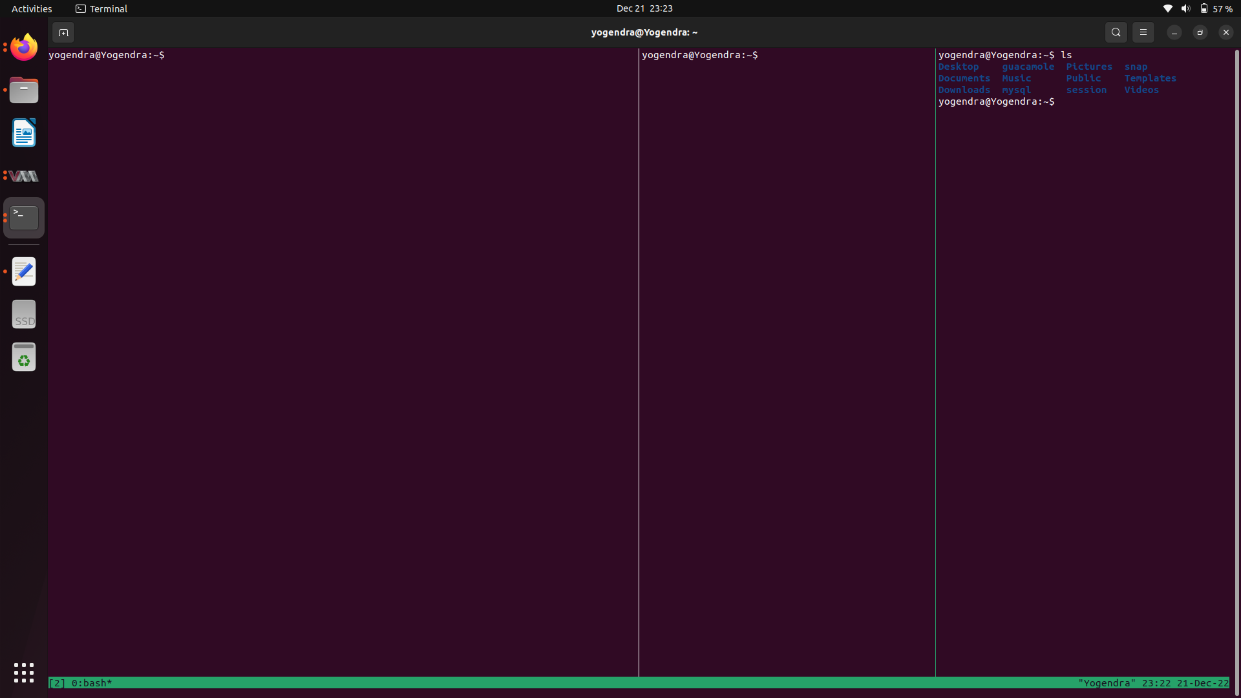**Question: To run a program and visualise memory leaks in Java and C language using Plumbr.**

Solution:

Link that I followed- <https://www.javatpoint.com/memory-leak-in-java>

**-> memory leaks program in C**

yogendra@Yogendra:~$ cat leak.c

#include <stdio.h>

#include <stdlib.h>

int main()

{

int *ptr, i;

ptr = (int *)malloc(sizeof(int) * 5);

for (i = 0; i < 5; i++)

{

ptr[i] = i;

}

for (i = 0; i < 5; i++)

{

printf("%d\n", ptr[i]);

}

//memory leak

//free(ptr);

return 0;

}

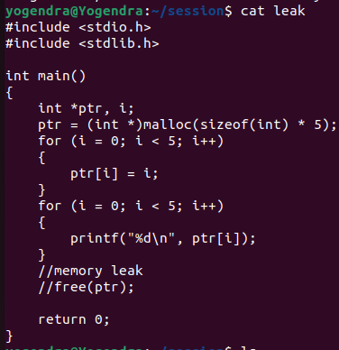

yogendra@Yogendra:~$ ./leak

0

1

2

3

4

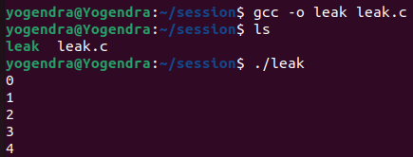

installed valgrind for checking the memory leak by executing the following command:

yogendra@Yogendra:~$ **sudo apt install valgrind**

If the above mentioned commands don't work, try the following command:

**sudo snap install valgrind --classic**

Then, Run the following command to check the memory leak (for C programs)

valgrind ./<c_program_file_name>

In my case, it is **valgrind ./leak**

Here is the output of 'valgrind ./leak' command:



